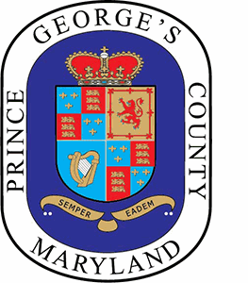
Prince George's County
QUALIFIED DATA CENTER TASK FORCE
Meeting Agenda

Wednesday, July 9, 2025 11:00 AM M-NCPPC Largo Headquarters

WELCOME

ATTENDANCE

DISCUSSION

- Recap of Previous Meeting

- Review and Approval of Minutes – June 11, 2025

- Recap of Data Center Tour -Loudoun County

- Data Center Materials Overview –James Hunt

- Data Center Community Meetings in July 2025
- Guest Speakers
  - Patrick Murray – Frederick County’s Data Center Experience
  - Environmental Impacts on Water- WSSC Representative
  - Environmental Impacts on Energy- Exelon Representative
- Other Topics

CLOSING REMARKS

NEXT MEETING

ADJOURN

