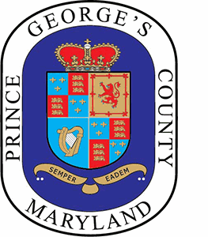
Prince George's County

PLAN PRINCE GEORGE'S 2035 IMPLEMENTATION AND INFRASTRUCTURE TASK FORCE
Meeting Agenda
Monday, October 28, 2024 4:00 PM Committee Room 2027

WELCOME
ATTENDANCE
DISCUSSION
- Recap of last meeting
- Review and approval of June 10th and September 26th minutes
- Data Collection Reports for FY25
- Results from the survey requesting ideas for future agendas
- Other Topics
CLOSING REMARKS
NEXT MEETING
ADJOURN

